**Batch: D - 1 Roll No.: 16010122096**

**Experiment No. 1**

|  |
| --- |
| **TITLE**: Design and animate the following:Pendulum /Collision of object /Water waves |

**AIM:**

Use the Blender software or any other open source software to create and animate

All Batch needs to Design Donut object

D1: Pendulum

D2: Collision of object

D3: Water waves

**______________________________________________________________________**

**Expected OUTCOME of Experiment:**

Create and animate a realistic pendulum motion using Blender and understand the basic concepts of Computer Graphics.

**_____________________________________________________________________**

**Books/ Journals/ Websites referred:**

YouTube

**_____________________________________________________________________**

**Steps to perform:**

1. Set Up the Workspace
2. Create the Pendulum
3. Position the Pendulum
4. Parent the Objects
5. Set the Pivot Point
6. Animate the Pendulum
7. Set Physics Properties
8. Adjust Animation Timing
9. Add Lighting and Camera
10. Render the Animation
11. Review and Refine
12. Save and Export

**Drive or GitHub/ google drive link:**

**Donut:**

<https://drive.google.com/file/d/1qGtFADERiwyyypD-UcBxkvRjaOo8aimS/view?usp=drive_link> **Pendulum:** <https://drive.google.com/file/d/1CrXRcW9VKnoI5zUrUFXkWAbgEkKRqDjo/view?usp=drive_link>

**Output(s) (Screen Shots):**

**Donut:**

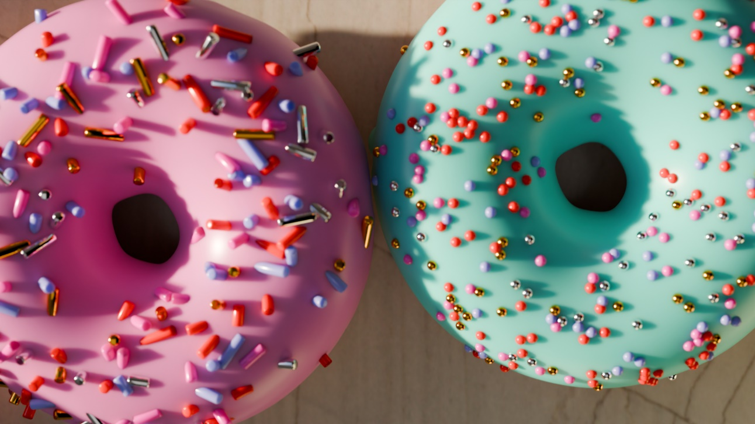

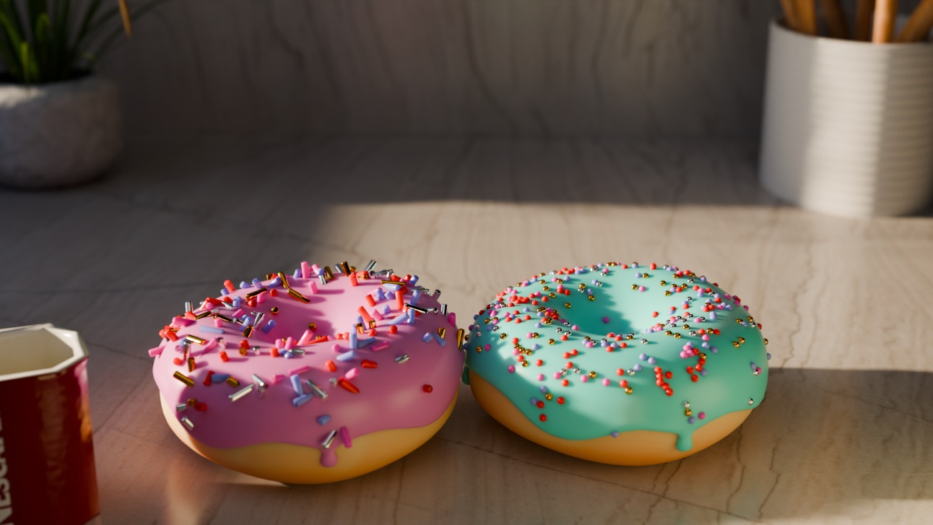

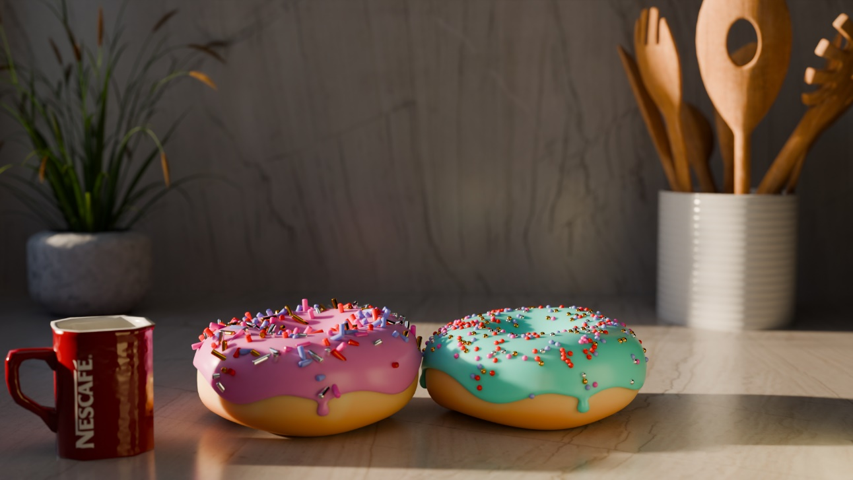

**Pendulum:**





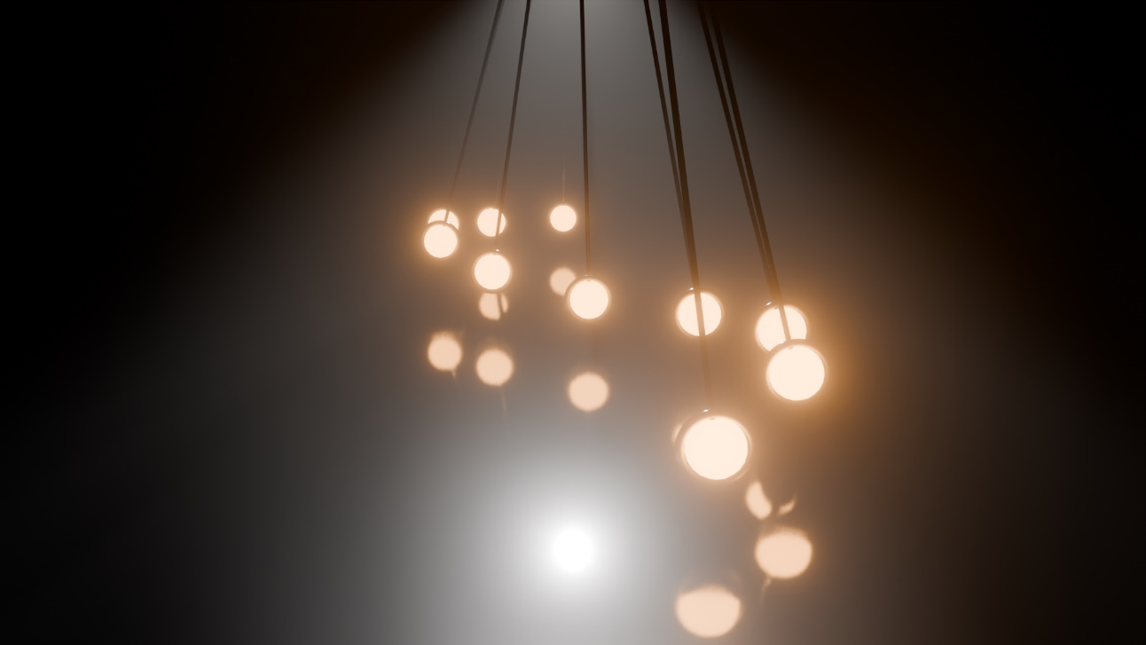

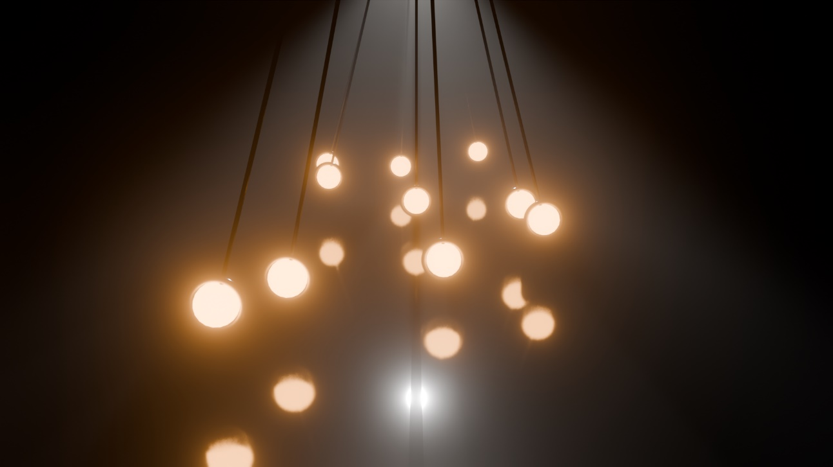

**Conclusion and discussion:**

In conclusion, creating and animating a pendulum in Blender involves setting up the workspace, modeling the pendulum, animating its motion, and fine-tuning physics properties. This experiment enhances understanding of animation principles and software tools, providing practical experience in creating realistic simulations. The final animation showcases effective pendulum dynamics.